Knowledge essay

Philip Dumaresq

Cities are environments that we create for ourselves to live in. They house industries, families, facilities and services. They are one of the biggest developments that the industrial age and consequently, modernism brought us. But are our cities going in a direction that continues to reflect that modernity, or are they looking different to us now?

Everyone can look at an image of the New York skyline and point out the empire state building. It’s the tallest building in the city and one of the most iconic buildings in the country. It’s a building that once represented a great construction by humans. It was built in 1931 and is still the tallest building in the city today. At a time, it was amazing, but now we get bored of it. As we see these buildings our expectations grow higher. We watch sci-fi movies and see concepts in those that now we beg for. And so we build to resemble things that are made to look like they’re from the future and somehow that’s more desirable. When we look at an image of the Shanghai skyline, it’s something unfamiliar and that makes it more desirable. It doesn’t look like any other city because it has architecture that’s a lot more progressive than that of New York. But the real difference between the two is that while New York was made at a time where they were trying to jam as many people into the city as possible almost 90 years ago, Shanghai was a city that’s designed not just to hold people, it was built to look good too. We’ve moved beyond just wanting to make it work, we have a need to make things look more desirable now too. For over a century we’ve been making buildings the same way- very blocky and squared off. Cookies cutter like. We got bored of those things and now we look at other cities that aren’t the same and end up far more impressed and those places become more desirable. We’ve stopped meeting our immediate needs and we look more towards the future than ever before. Now we have people that spend their time imagining and designing cities of the future. Look at the two photos that I’ve got that look like futuristic cities. One of them is very pristine and beautiful while the other is very busy, but both very progressive. I think that this planning of our future and breaking out of building for what we need and into what we want is our escape from what we’d considered to be modernism.

Now, one could argue that as a society we have to progress. We have to move forward. This change in the mindset of thinking ahead as opposed to thinking about now isn’t about moving out of modernism, it’s about trying to plan a future that can be lived. Styles in buildings have always been changing as time goes on. We build in excess because eventually it will be needed. We build things to be beautiful not because we get bored of things because we simply prefer them. There’s nothing new about wanting something that looks better. We’ve always had styles of fashion for people, so now we’ve simply expanded that to styling for our cities. We want the places we live in to be clean and look nice. If anything, we wouldn’t want to live in places like Shanghai. Shanghai is so populated and has so much pollution that the city is covered in smog on a daily basis. You can look at it while there is none, but the truth is that most of the time, there will be. The city is dirty, and although aesthetically progressive in its architecture, the city is not a place you want to live in.

This is true- the majority of the cities that are as populated as shanghai or Beijing or Tokyo are covered in smog. But the point being made isn’t about the smog, it’s about the city looking more appealing. The smog can be fixed, we can change that. The point being made is about the aesthetics of the city. When we look at an image of Shanghai, we may not want to live there due to the pollution in the city, but we want to live there because the city looks like it’s very futuristic. The city is progressive. The city was built in the image of cities of our future and that’s what makes it more appealing. The city needs to be clean, it’s a place that’s barely livable as it is. But when we look at an image of the city we don’t think of that, we want to live in the future, we want to move past the cookie cutter cities that we live in today. Thinking about how we build and where we build isn’t something entirely new but is thought of in a new way.

In conclusion, I believe we have moved out of the modern era. We’ve moved into an era where we over build think decades or centuries ahead, we look towards the future on a scale much greater than we ever have before. I think this progression towards the future is us moving out of modernism.

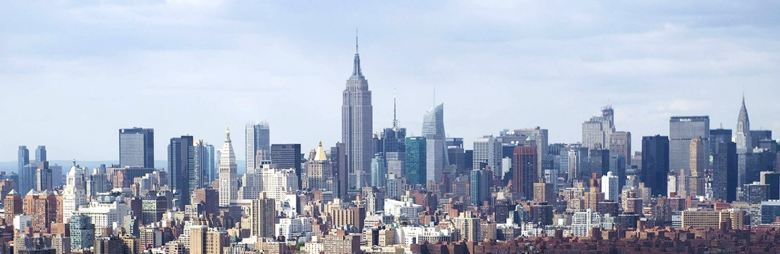

1. New York Skyline

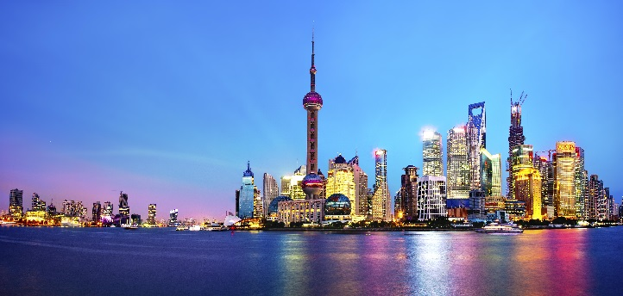 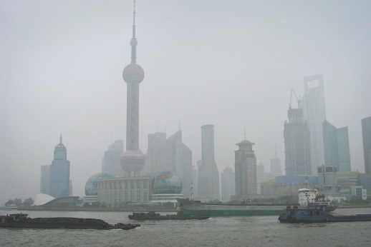

1. Shanghai Skyline 3. Shanghai smog

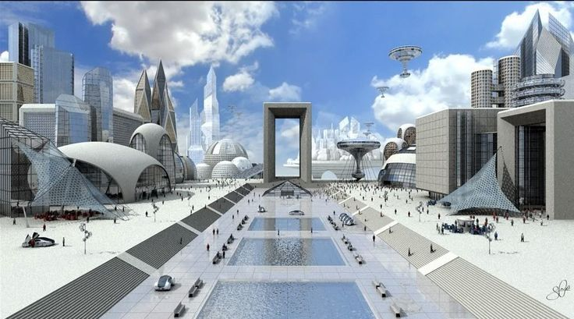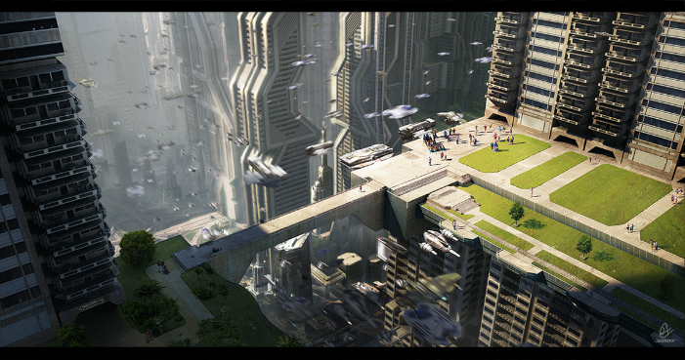

1. How we envision our future cities 5. Cities of the future